Version 4.0 Planning Document – School Canteen – Jeremy Roberts

Task 0: Explain what you are doing/ going to accomplish

I am going to create a website that manages a school canteen, it will manage the stock of items on the menu and students will be able to order food. I will create a program that stores the students name and what they ordered in an array. The inputs will be processed with a python bottle program and displayed on an html website.

**This version**: Just add images, Very small version, Not much planning needed for functionality

Task 1: Sketch interface design

No new interface

Task 2: Identify any classes required

No new class

Task 3: Identify information to be displayed

On the stock info page, I am adding a image for each food item plus a placeholder for new items

Task 4: Identify user inputs

No new user inputs

Task 5: Identify any constants or existing data if required

No new constants

Task 6: Identify indexed data structures

No new index data structures

Task 7: Determine what calculations are necessary

No calculations needed

Task 8: Develop a modular structure for your program

To add images to my site, I had to add some code to my python, all it does is tell the website where to find the images in the files:

New code I will add in pseudo-code:

In this route ‘/assets/<filename>’

Define a function called server_static(passing the parameters :filename, do this:

Return variable “static_file(with filename and the root equals assets folder)

Task 9: Define the functions identified

**Server_static:**

Very simple, this function runs when an image appears on a page, all it does it tell the html where to find the image (what folder)

Task 10: Address any relevant implications such as usability, functionality, legal/ethical requirements.

All Versions

When designing my website, I will take into account the implication of usability and functionality, meaning buttons will be labelled, a colour scheme that is easy to look at, the layout will make sense and be very basic, a school canteen website does not need to be complex, Because I want kids or people who arn’t so good at computers to be able to run my program. The website should not breach and legal and ethical requirement, it will follow copy right laws, won’t be offensive etc..

**This version**: I made sure to not steal anyone’s images, all images are from a royality free site and downloaded legitimately with the creators permission, below I will link the stock image sites I got the images from.

**Place holder image**: <https://pixabay.com/illustrations/burger-icon-hamburger-fast-meat-2013191/>

**Other images**: [https://unsplash.com](https://unsplash.com/)

Hot dog image: <https://unsplash.com/photos/CRnTIhqbsyU>

Sushi image: <https://unsplash.com/photos/QGQQHTOjHlI>

Sandwich image: <https://unsplash.com/photos/NoczeWSAF_w>

Task 11: Document test cases for testing the program

**To see if my new code works:**

Test: reload the page and see if images appear

Expected outcome: the images will show

Actual outcome: the images showed

Fix: no fix needed

There is only one test case I can do for this, there is no other way to interact with images, my program doesn’t allow the user to upload images, so there is only one test case to use, and it works

Task 12: Refine the plan

No refining needed

Task 13: Document testing

Proof to show that my images appear:

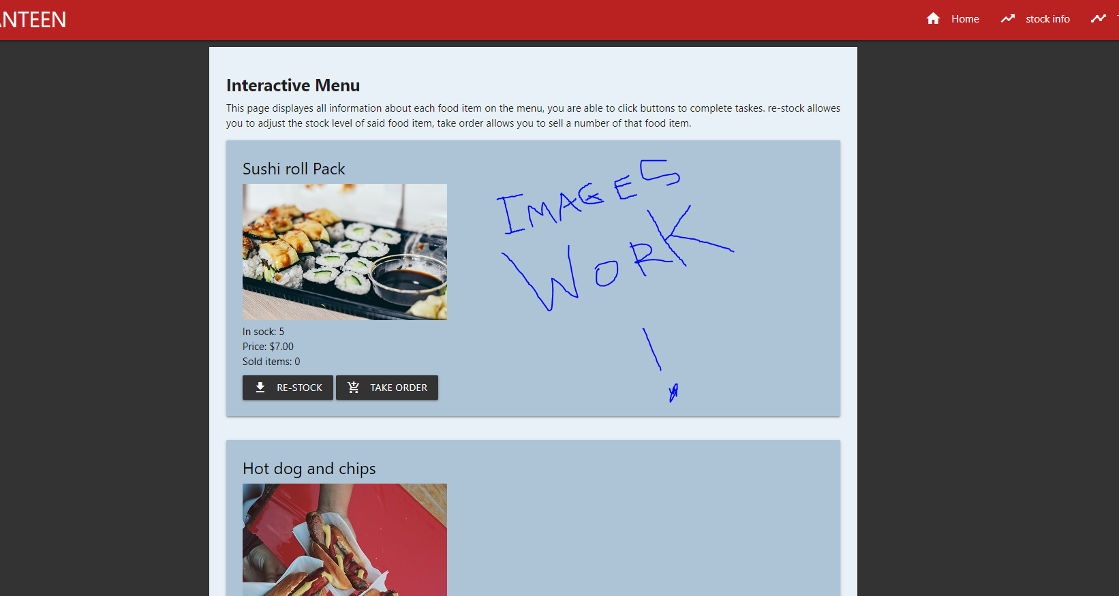

Task 14: Evaluation

The reason the addition of images gets a whole version and planning document to itself is because I was not intending to add images in the first place, but after adding them, I think it is a nice touch. It almost helps with the navigation of the page. There is only so much I can write in a planning document about adding images, while adding them I made sure to follow copyright laws. The previous version was the last version to add functionality to my python code, this evaluation is only about adding the image.